1119/2
Bahasa
Inggeris
Kertas 2
Ogos
2019

PEPERIKSAAN PERCUBAAN SPM 2019

BAHASA INGGERIS

Kertas 2

Dua jam lima belas minit

NAME: …………………………………………. CLASS:…………………………

JANGAN BUKA KERTAS SOALAN INI SEHINGGA DIBERITAHU

Arahan
For Examiner’s Use
Section
A
B
C
D
Total

1. Kertas soalan ini mengandungi 33 soalan.
2. Jawab semua soalan.
3. Bulatkan jawapan anda untuk Bahagian A di dalam
kertas jawapan yang disediakan.
4. Untuk Bahagian B, Bahagian C dan Bahagian D tuliskan
jawapan anda di ruang yang disediakan di dalam
kertas soalan ini.

Instructions
1. This question paper consists of 33 questions.
2. Answer all questions.
3. Circle your answers for Section A on the answer sheet
provided.
4. Write your answers for Section B, Section C and
Section D in the space provided on this question paper.

Section A
[15 marks]
[Time suggested : 25 minutes]

Look at the picture below and answer the question that follows

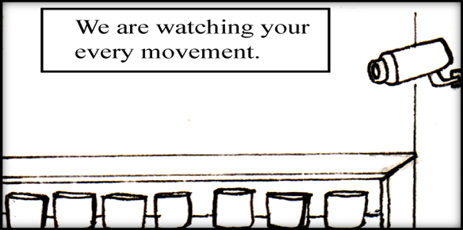

 | - What is the purpose of the CCTV and the notice?
 |  | A | To warn shoppers
 |  | B | To prevent shoplifting
 |  | C | To take photographs of shoppers
 |  | D | To keep an eye on the amount of goods sold

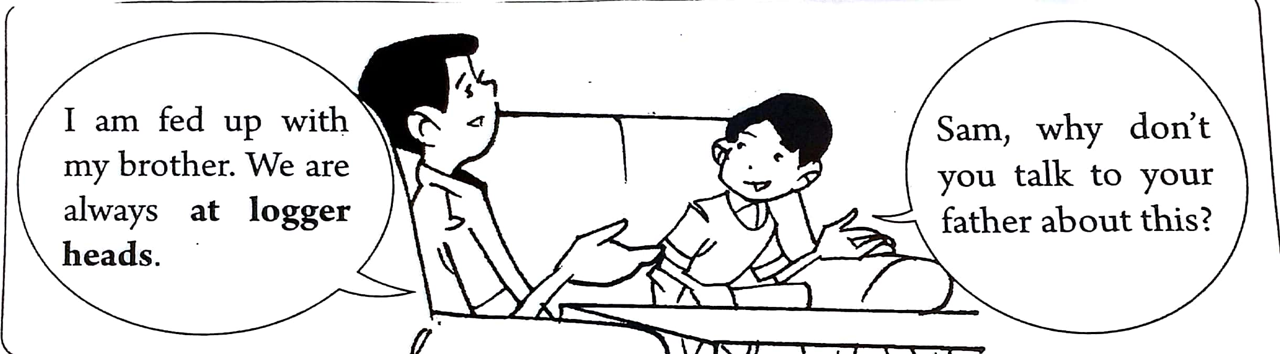

2. From the dialogue above, the phrase at logger heads means that Sam and his brother are

- always banging their heads
- always exchanging ideas
- always arguing with each other
- always thinking of interesting things to do.

CLERK
Requirement:
SPM with 3 credits
Good communication skills
Fluency in English
2 years working experience in a reputable hotel

If you are interested, please send your resume to ramli@raya.com or contact Encik Ramli at 012-1234567

3. Which of the following qualification is not essential for the position advertised?
- Proficient in English and Malay languages
- Working experience in the relevant area
- Possess good communication skills
- SPM qualifications

Lee lived alone. He looked older than fifty years; his skin was sun-baked and blemished, his forehead covered with deep lines. He has few teeth which were rarely seen as he had few reasons to smile. His only companion was his cat, smiley whom he loved. Smiley offered unquestioning love, loyalty and affection.

4. Based on the extract above, we can conclude that Mr Lee
- has no family
- is a very old man
- is a very lonely man
- does not like to smile because he has no teeth

Study the pie chart below and answer the question that follows.

Percentage of Car Thefts, 2009



5. Based on the pie chart above, which of the following statements it true?

A. The least number of car thefts occur in parking lots
B. A low percentage of car thefts occur at shopping areas
C. A high percentage of car thefts occur at places of work
D. The most number of car thefts occur in residential areas

HOW WASTE PAPER IS RECYCLE
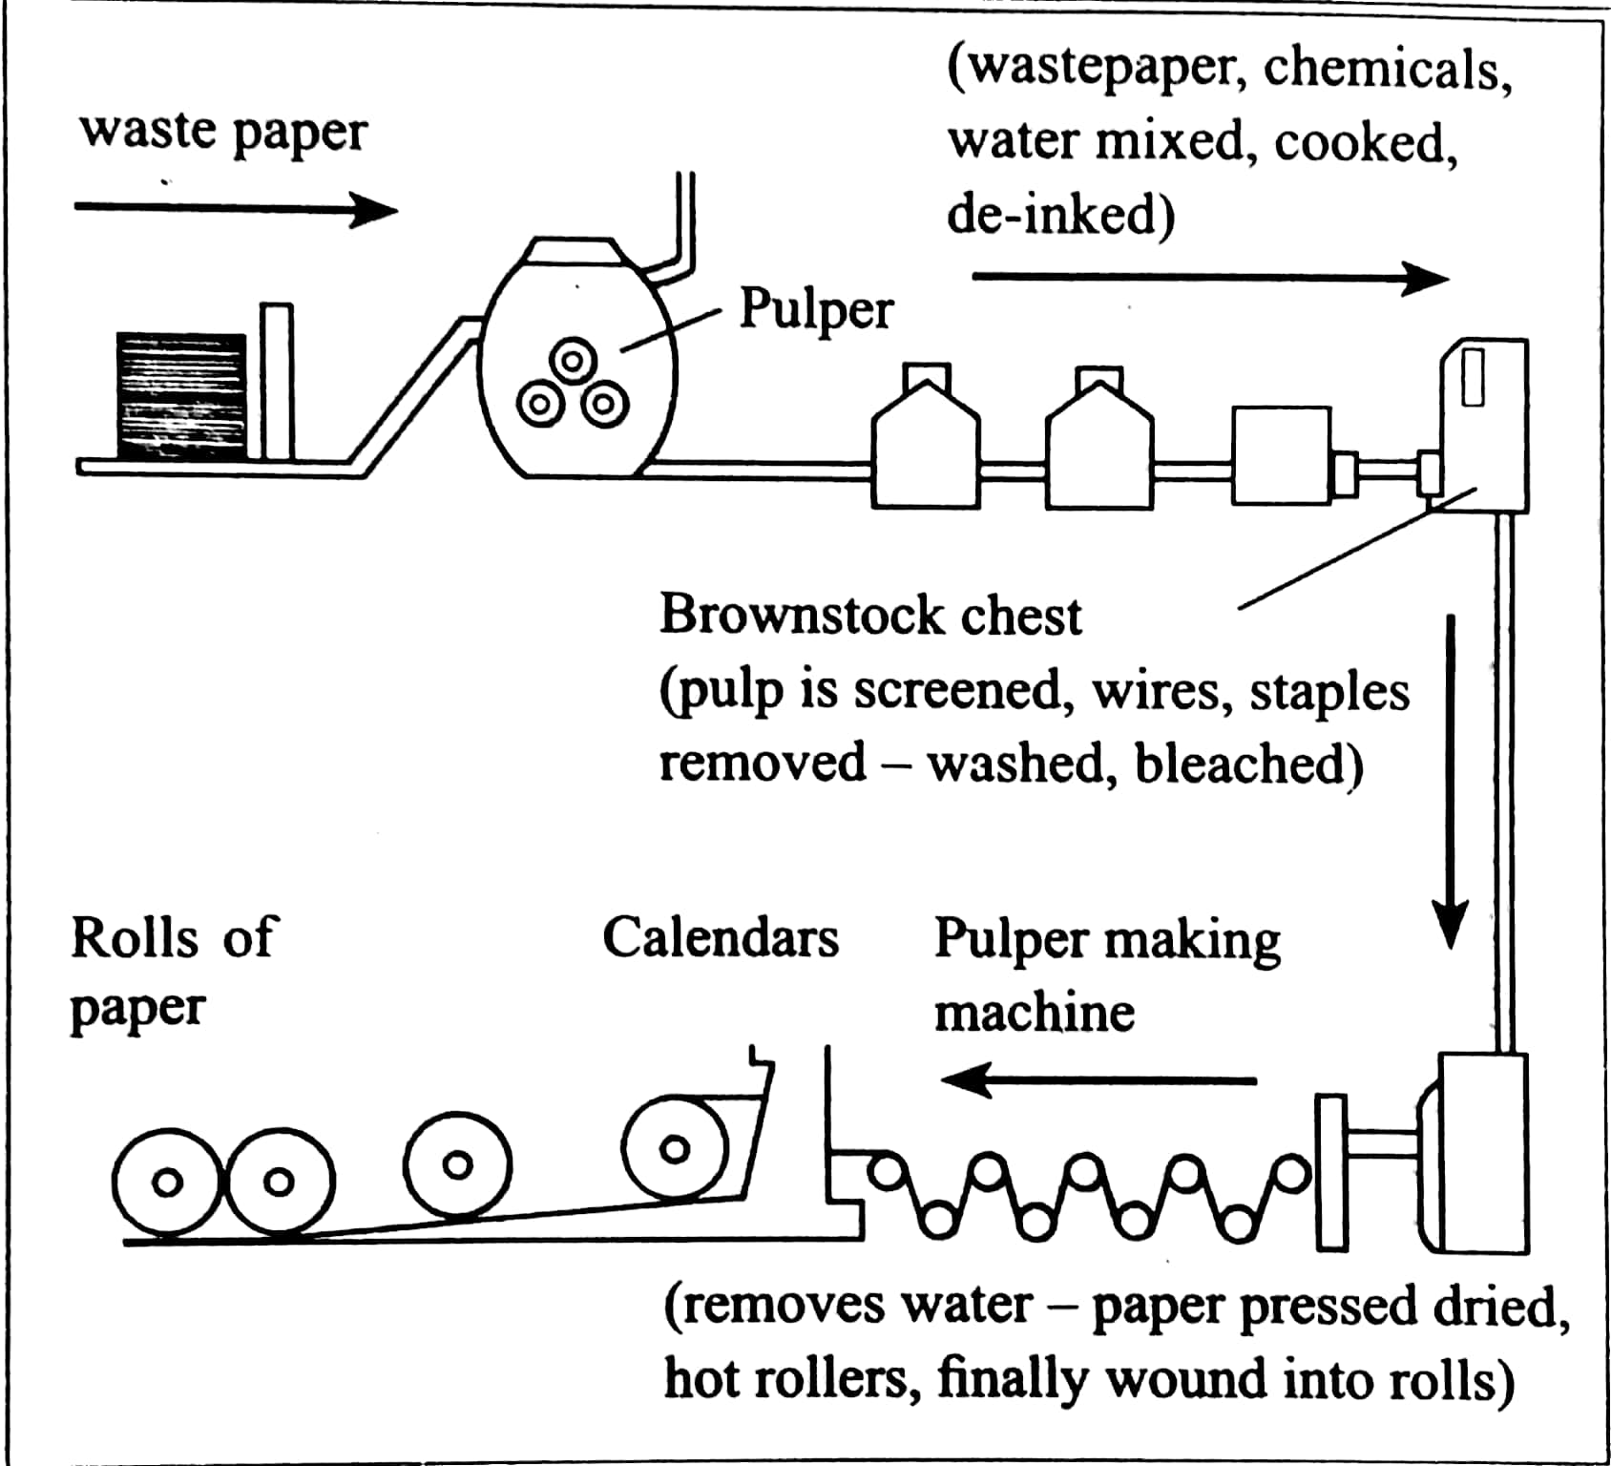
6. From the flow chart above, which of the following statement is true?
- Wastepaper is mixed in the pulper with chemicals.
- Wastepaper is cooked in the pulper with oil.
- Pulp is screened in the Pulper Making Machine.
- The final products of recycling are rolls or cloth.

THE CLASSICAL GUITAR SOCIETY
requests the pleasure of the company of
Mr David Yap
to a concert performed by Ms Chin May Ling
on Saturday, 6 May 2010 at 8.00 p.m.
at La Musique Ballroom, Calton Hotel
Dress code: Formal

7. The invitation above informs us that?

A. Guests should wear formal clothes
B. Guests may dress as comfortably as they like
C. Guests and friends may dress in formal clothes if they like

Nice to see and nice to hold
but
once broken, considered SOLD!

8. Where can you find this notice in a departmental store?

A. The book and magazine section
B. The kitchenware section
C. The ladies wear section
D The dry food section

Questions 9-15 are based on the following passage. Choose the best answer to fill in each blank.

Salads are simple dishes normally served during meals. A salad consists of small pieces of food which …(9)….mixed together with a type of sauce or salad dressing. Salad can be made using a variety of available…(10)…..including vegetables, fruits, cheese, cooked meat, eggs and grains. There are many types of salads. Fruit salads, green salads, vegetable salads, bound salads are just …..(11)….. examples.
A green salad is made using green, leafy vegetables like lettuce and spinach …..(12)…. The vegetable salad can be a mixture of tomatoes, cucumbers, carrots and peppers. A fruit salad usually …..(13…) melons, strawberries, grapes or apples.
……(14)….. a salad is not too difficult but one needs to be careful in choosing the best ingredients to produce tasty, satisfying salads that people can ….(15)…. In a case of a problem, the Internet will always be there to provide us with all sorts of salad recipes.

9. A. are B is C. can D. were
10. A. materials B. substances C. ingredients D. components
11. A. a few B. a lot C. a little D. many
12. A. meanwhile B. whereas C. thus D. nevertheless
13. A. contain B. contains C. containing D. contained
14. A. Prepared B. Prepare C. Prepares D. Preparing
15. A. relish B. buy C. cook D. garnish

SECTION A ANSWER SHEET

1. A B C D
2. A B C D
3. A B C D
4. A B C D
5. A B C D
6. A B C D
7. A B C D
8. A B C D
9. A B C D
10. A B C D
11. A B C D
12. A B C D
13. A B C D
14. A B C D
15. A B C D

Section B
[ 10 marks ]
[ Time suggested : 25 minutes ]
Questions 16 to 25
Read the following report and complete the graphic organizer on the following page.

Fun Facts:
The more happy people you associate with, the happier you become.
Being connected to happy people improves a person’s happiness.

Happiest Countries
Fans of Denmark must be even happier than usual: Denmark has retaken the title of "world's happiest country," knocking Switzerland into second place.
Denmark and Switzerland were closely followed by Iceland, Norway and Finland, according to the World Happiness Report Update 2016, released Wednesday in Rome by the Sustainable Development Solutions Network for the United Nations.
Denmark won the title three of the four times the report has been issued, losing to Switzerland only once.
People in Burundi are the least satisfied with their lives, according to the survey of 156 countries, but residents of Benin (153rd place), Afghanistan (154), Togo (155) and Syria (156) aren't doing much better.
The United States ranked 13th in overall happiness, lagging behind Canada (6), the Netherlands (7), New Zealand (8), Australia (9), Sweden (10), Israel (11) and Austria (12). Germany came in 16th place, while other superpowers -- the United Kingdom (23), Japan (53), Russia (56) and China (83) -- were markedly lower.

Some countries that saw drops suffered economic and political turmoil -- including Greece, Italy and Spain -- while Ukraine's political trouble and violence likely caused a significant drop in happiness there.

Strictly focusing on financial well-being can obscure the larger picture.
John Helliwell, Co-director of the Canadian Institute for Advanced Research

Rather than taking a narrow approach focused solely on economic growth, we should promote societies that are prosperous, just, and environmentally sustainable.
Jeffrey Sachs, Director of the Earth Institute at Columbia University

Iceland and Ireland both suffered through banking crises that dramatically affected their economies but didn't greatly affect their happiness, according to the report. What both countries have is a high degree of social support, enough to put Iceland in third place and Ireland in 19th place this year, according to the report.

Questions 16 to 25
Using the information given, complete the graphic organizer below.
REPORT
16 Title: …………………………………………………
17 Publisher: …………………………………………………
18 Happiest country: …………………………………………………
19 Least happy country: …………………………………………………

FACTORS CONTRIBUTING TO UNHAPPINESS
20 People of Greece, Italy and Spain :
…………………………………………………..
21 People of Ukraine:
…………………………………………………..
22 People of Burundi:
…………………………………………………..



OTHER FINE POINTS
- 23 ……………………………………………………... helps Iceland and Ireland remain as happy countries.
- Jeffrey Sachs and John Helliwell are of the opinion that
24 ……………………………………………………………………………………………

- The report implies that to stay happy a person should
25 ……………………………………………………………………………………………

Section C
[25 marks]

[Time suggested: 50 minutes]

Questions 26 to 31 are based on the following passage.

1 | Click, click, click. The sound of the alarm clock woke me up to a new dawn. Raising my hands, I grunted as I hit the device, hoping it shuts up forever. Then like a jolt it came to me, "It is really today. I will officially become an undergraduate today". All the months of late-night reading for SAT - and my mum's fiery-red prayers against demons, in my family and out of it, who will think of trying to withhold her son's admission - had finally paid off. The University of Nigeria, Nsukka awaits. My mum's shout prompting me to wake up for prayers confirmed it. My heart swelled up again at finally making it to the University. My people don't call it Màhàdúm - know it all - for nothing. "Frankboy, you are good," I kept saying to myself. | 5  10
2 | It is quite a feat to get into a University in Nigeria at 15, and my mum did not forget to mention it at the family prayer that was held for her ‘illustrious son’. I didn't mind as oblations upon oblations were poured on my head. I was just too overjoyed. I smiled through it all as mummy called on all the archangels in the universe to guard and guide me - as if I was the only one in the world - and for all the demonic armies to bow before me. | 15
3 | After the prayers, I got different advices from different people. While some told me to shy away from drinks, others told me to neither look at ladies nor talk to them, while yet another group told me to always fear God, and not to join any cult group. My dad summed it up with, "Frank, you are now a University student and that makes you an adult. Although you are just 15, you are now a man. Hold unto God, read your books, and desist from evil. In our family, we are neither thieves nor liars. Ìmàrá àsù, súò n'íkwé, ímàghí àsù, súò n'àlà (if you know how to pound, pound on the mortar, if you do not, use the floor, which means that I can choose to heed good advice or not)." I half listened through it all, as I was now impatient to go, but I was too happy to be rude to anyone. | 20  25
4 | My dad drove me out to the bus stop, where I would get a bus to Nsukka, the University town. Although my mum wanted him to drive me to the school - fearing that I was too little to make the journey - dad stuck to his guns, insisting I make the journey alone. "He has to be his own man, and cuddling him would not help that", he said. That was how I travelled to a far place alone for the first time. | 30
5 | At the bus stop, seeing myself alone with no familiar face around, most of my bravado and exuberance fled. It became very clear now to me that I was going off again to be all by myself. At least in secondary school I was little enough to have my parents visit me without being embarrassed. Now I am a "big boy," and big boys don't get frequent visits from their parents. Thoughts of the stories I have heard about the University loomed large on my mind: how the school was so big and the students were so many that it would take weeks or months to notice someone's disappearance; and how cultists force students to join or get killed. All that ran through my mind as I sat in the bus, waiting for other passengers to come and fill up the seats for our departure. I was so engrossed that I didn't hear the voice or notice her until she stretched out her hand to tap me on the shoulders, "Excuse me, I asked if someone is seated beside you," I heard her say. "No, no, no, not really", I confusedly stammered in response. "Alright then, adjust a little for me to sit," she told me. Before I could collect my thoughts, she had already sat down beside me, smiling at me as she did so. | 35  40  45
6 | "My name is Jennifer, what's yours?" she asked. When I told her my name, she told me it's a nice name. For the next three hours, Jennifer and I spoke about a lot of things, although I must confess, she mainly spoke, while I listened. By the time we were halfway to our destination, I knew that Jennifer is an only child; that she likes movies a lot; that she is a second-year student of the same University; that she thought I am a listener, and she liked it - and me - a lot, and that she knew I would enjoy the school very much. | 50
7 | Two hours later, seeing the gates of the school, I looked down at the sleeping form of Jennifer leaning contentedly at the dirty window of the bus, and I knew then that no matter what, the University holds a lot of surprises for me. "Jennifer, Jennifer, wake up, we are here," I smiled as I roused her from sleep. | 55
By Frank Diplomat
Born 1993, M, from Lagos, Nigeria

26. From paragraph 1,
(a) What actually jolted the writer to wake up?

…………………………………………………………………………. ……………….
[1 mark]

(b) How did the writer know that he was accepted into the university?

…………………………………………………………………………………………..
[1 mark]

- From paragraph 3, what are the advices given by the writer’s father to him?

- ………………………………………………………………………………………[1 mark]

- ………………………………………………………………………………………[1 mark]

- ………………………………………………………………………………………[1 mark]

- From paragraph 4, why do you think the writer’s father refused to drive him to his university?

………………………………………………………………………………………………

………………………………………………………………………………………………
[1 mark]
- From paragraph 5,
- What made the writer’s bravery and liveliness to flee?

…………………………………………………………………………………………..

…..………………………………………………………………………………………
[1 mark]

- Which word has the same meaning as the word appeared?
…..………………………………………………………………………………………
[1 mark]

- In your opinion, what do you think the writer did after he descended the bus? Provide a reason to support your answer.

Action:

…..…………………………………………………………………………………………..
[1 mark]

Reason:

…..…………………………………………………………………………………………..
…..…………………………………………………………………………………………..
[1 mark]

- Based on the passage, write a summary on:
- The preparation the writer had to face and listen to before going to the university

Credit will be given for use of own words but care must be taken not to change the original meaning.

Your summary must :
- be in continuous writing (not note form)
- use materials from line 6 to line 37
- not be longer than 130 words including the 10 words given below.

Begin your summary as follows:

Hard work and perseverance are the price to pay when…
[15 marks]

………………………………………………………………………………………………...………………………………………………………………………………………………...………………………………………………………………………………………………...………………………………………………………………………………………………………………………………...………………………………………………………………………………………………...………………………………………………………………………………………………...………………………………………………………………………………………………………………………………...………………………………………………………………………………………………...………………………………………………………………………………………………...………………………………………………………………………………………………………………………………...………………………………………………………………………………………………...………………………………………………………………………………………………...………………………………………………………………………………………………………………………………...………………………………………………………………………………………………...………………………………………………………………………………………………...………………………………………………………………………………………………………………………………...………………………………………………………………………………………………...………………………………………………………………………………………………...………………………………………………………………………………………………………………………………...………………………………………………………………………………………………...………………………………………………………………………………………………...………………………………………………………………………………………………………………………………...………………………………………………………………………………………………...………………………………………………………………………………………………...………………………………………………………………………………………………………………………………...………………………………………………………………………………………………...………………………………………………………………………………………………...………………………………………………………………………………………………………………………………...………………………………………………………………………………………………...………

SECTION D
[20 marks]
Question 32
The following questions are based on the poem below.
The Living Photograph
My small grandmother is tall there,
straight-back, white broderie anglaise shirt,
pleated skirt, flat shoes, grey bun,
a kind, old smile round her eyes.
Her big hand holds mine,
white hand in black hand.
Her sharp blue eyes look her own death in the eye.
It was true after all that look.
My tall grandmother became small.
Her back round and hunched.
Her soup forgot to boil.
She went to the awful place grandmothers go.
Somewhere unknown, unthinkable.
But there she is still,
in the photo with me at three,
the crinkled smile is still living, breathing.

- Give two descriptions of the persona’s grandmother’s appearance.
(i) __________________________________________________________________
(ii) __________________________________________________________________
[2 marks]
- Why did the grandmother forget to boil her soup?
_____________________________________________________________________
[1 mark]
- Do you consider the grandmother as courageous? Give your evidence from the poem.
_____________________________________________________________________
_____________________________________________________________________ _____________________________________________________________________
[2 marks]
33 The following are the novels studied in the literature component in English Language :
Captain Nobody - Dean Pitchford
Sing to the Dawn - Minfong Ho
Dear Mr Kilmer - Anne Schraff

Choose any one of the novels above and answer the question below.
“Friendship is selfless love, care and respect”
Based on the above, write about a character who shows selfless love to his/her friends. Support your answer with close reference to the text.
[15 marks]
______________________________________________________________________________________________________________________________________________________________________________________________________________________________________________________________________________________________________________________________________________________________________________________________________________________________________________________________________________________________________________________________________________________________________________________________________________________________________________________________________________________________________________________________________________________________________________________________________________________________________________________________________________________________________________________________________________________________________________________________________________________________________________________________________________________________________________________________________________________________________________________________________________________________________________________________________________________________________________________________________________________________________________________________________________________________________________________________________________________________________________________________________________________________________________________________________________________________________________________________________________________________________________________________________________________________________________________________________________________________________________________________________________________________________________________________________________________________________________________________________________________________________________________________________________________________________________________________________________________________________________________________________________________________________________________________________________________________________________________________________________________________________________________________________________________________________________________________________________________________________________________________________________________________________________________________________________________________________________________
___________________________________________________________________________________________________________________________________________________________________________________________________________________________________________________________________________________________________________________________________________________________________________________________________________________________________________________________________________________________________________________________________________________________________________________________________________________________________________________________________________________________________

KERTAS SOALAN TAMAT

